
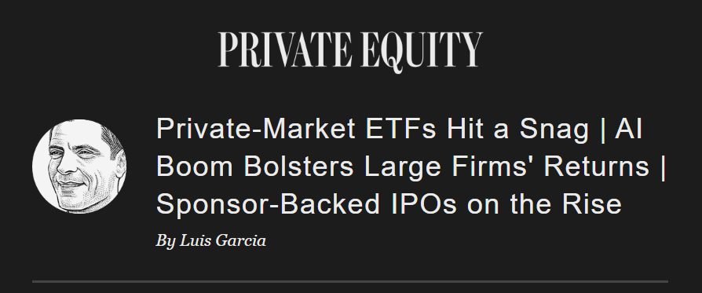
Good morning! Large firms are making big bets both on the expansion of artificial intelligence and the opening of private markets to individual investors. Such long-term trends are bound to have side effects.
For example, institutional investors have poured capital in exchange-traded
funds intended to bring private investments to the masses, our Chris Cumming reports.
Meanwhile, investments in AI infrastructure are lifting large firms' returns, but also sowing uncertainty in the software sector, my other colleague Maria Armental writes.
And the Journal's Mark Maurer reports that IPOs by private equity-backed companies have already surpassed last year's total and amount to the most in five years, with five months to go in 2026.
Now on to the news...


Today's Top Stories
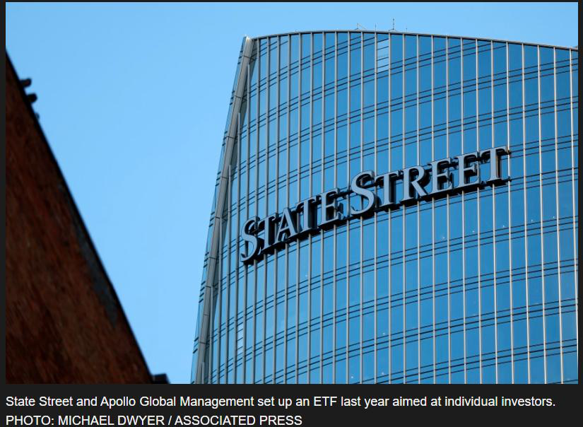
Exchange-traded funds that aim to bring private investments to the masses have encountered a hitch: Institutional money the mom-and-pop savers the funds are designed to serve, Chris Cumming writes for WSJ Pro. Since early last year, investment firms have gathered billions of dollars for ETFs that combine public and private assets, a new breed of vehicles on the cutting edge of Wall Street’s—and the —push to toprivate markets.
Artificial intelligence how private-equity firms do business—and with whom, WSJ Pro's Maria Armental writes. The latest quarterly earnings reports from big publicly traded firms showed the extent to which AI now drives financial performance and has turned former rivalries into technological collaborations, including multibillion-dollar ventures with leading AI startups OpenAI and Anthropic.
Private-equity firms to take companies public as pressure to return capital to fund investors continues to mount, Mark Mauer writes for The Wall Street Journal. There have been 21 U.S.-listed IPOs of private equity-backed companies this year through Aug. 5, the most since 2021, according to Dealogic. That compares with 20 in all of 2025 and 16 the year before. Blackstone President Jonathan Gray declared 2026 the “year of the IPO” on an earnings call earlier this year.

Big Number
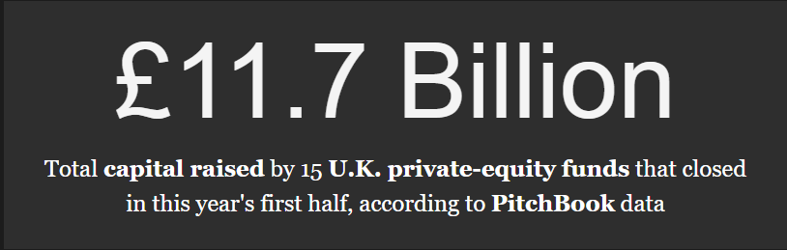
Deals
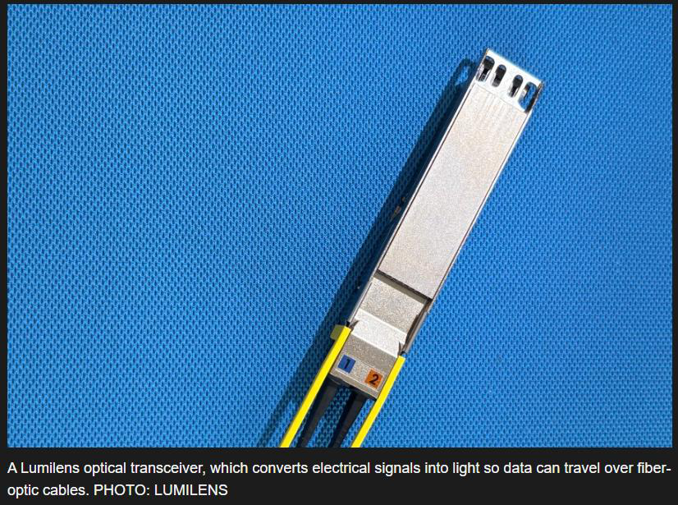

Atreides Management, Bain Capital and Spark Capital were among the leaders in a growth investment of more than $700 million optical-interconnection technology startup Lumilens in a deal that valued the data center-focused company at $5.5 billion, Anissa Gardizy reports for the Journal. The San Jose, Calif.-based company's products are used to link artificial-intelligence chips using light instead of electricity.
Buyout firm KKR & Co. its nearly $3 billion investment supporting accounting firm Crowe, a majority stake in Crowe Advisory, the business unit that provides nonattest services such as tax and other consultations. Chicago-based Crowe specializes in working with midmarket businesses and the licensed certified public accounting firm will continue to provide audit and other services alongside Crowe Advisory.
Infrastructure investor I Squared Capital over Oaktree Capital
Management and Pacific Equity Partners in the bidding for public space advertising company OOh!Media, Australia's Financial Review reports, citing people it didn't name. I Squared raised its offer to 1.70 Australian dollars per share, equivalent to $1.20. Last month the company reported that bids as of June 15 had reached A$1.65.
A roughly $2.71 billion deal to private Canadian renewable energy
company Boralex by Brookfield Asset Management and Caisse de Depot et Placement du Quebec all regulatory hurdles and is expected to wrap up by Friday, the company said.
Redfearn Capital led a $628 million acquisition of a collection of 53 industrial properties with TPG's real-estate arm investing alongside, according to an emailed news release. The partners acquired the holdings from DRA Advisors, a real-estate investment fund manager in New York, according to a Redfearn spokeswoman.
Altair Industries, a private-equity firm focused on midmarket deals across the aerospace, defense and mission-critical industrial sectors, Central Wire Industries, which manufactures specialty alloy wire and cable products.
Midmarket investor Triton Partners to acquire German manufacturer United Initiators from Equistone Partners Europe. The specialty chemicals maker's active oxygen products are used to trigger polymerisation and for their oxidation potential.
United has more than 800 employees working in nine plants and two warehouses worldwide. Equistone first the business in 2016.
New York-based firm MFG PartnersUnited Group Services, a Cincinnati-based provider of construction, retrofit and maintenance services that include industrial

piping, rigging, millwright, structural steel, insulation and scaffolding, as well as heating and cooling systems, among other services.
The property investment arm of TPGMadison International Realty as a minority partner in German student housing developer and manager Home & Co. TPG Real Estate Partners is retaining majority ownership of the company, which it since its inception in 2019.
The asset-management arm of Macquarie Group in Sydney more than 8,700 wireless telecommunications tower sites in Brazil and 250 more in Colombia from IHS Holding, closing a roughly $683 million leveraged deal announced in February.
Investor and operator LS Power to buy a 606-megawatt natural gas-fired plant in Texas, the Brazos Valley Energy Center, from Constellation Energy, which is selling the plant to meet regulatory requirements to its acquisition of power plant
operator Calpine early this year. The Brazos Valley generating station is located near Houston.
Indonesia sovereign-wealth fund Danantara Investment Management $2.5 billion for a 25% interest in a joint venture established with Brazilian meatpacker JBS Group. The venture oversees JBS operations in Australia and New Zealand. An additional $2.5 billion in investment capacity may be provided to the joint venture to fund
acquisitions and expansion including in Indonesia and Southeast Asia, Danantara said.
Thoma Bravo final court approval in Ontario for its roughly $463.8 million
acquisition of Toronto-listed Kneat.com and expects to close the take-private Tuesday. The Ireland-based software maker announced the deal in June.

Add-On Deals
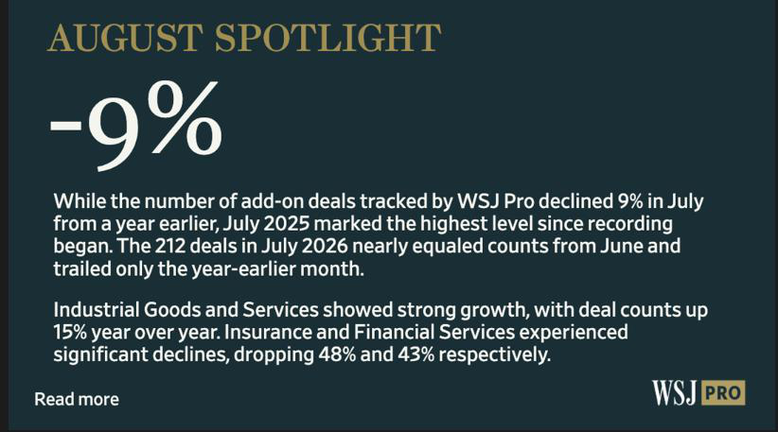
Our add-on deal interactive tool allows you to sort and analyze volumes of add-on deal data compiled by WSJ Pro.
Exits
Providence Equity Partners-backed analytics software supplier DoubleVerify
Holdings acquired by strategic buyer Nielsen Holdings at an enterprise value of about $2.15 billion, Josh Beckerman reports for the Journal. Providence first backed the New York company in 2017 and took it public in 2021, retaining shares that by earlier this year amounted to about 18.2 million and represented a nearly 12% equity interest, a regulatory filing shows. Nielsen is paying $13.60 a share.
Abry Partners in Boston its stake in wealth adviser Prime Capital Financial, with Carlyle Group acquiring a minority interest in the Overland Park, Kan.-based business. Abry first backed the company in 2023, according to the firm's website.

Funds
Willow Tree Credit Partners a multiasset continuation fund with about $730 million in a deal led by HarbourVest Partners in Boston. Willow Tree Fund II-CV holds a bundle of about 130 securities consisting mainly of first-lien loans made to midmarket businesses in 2020 and 2021 through the New York firm's second flagship fund.
Funds-of-funds sponsor Pathway Capital Management a $235 million customized fund of funds for an Asia-based institutional investor. in June by Clearlake Capital in Santa Monica, Calif., Pathway manages assets of about $95 billion and aims to make primary fund commitments and co-investments focusing on smaller and midsize targets through the new fund.
People
Venture debt investor Runway Growth CapitalMichael Rovner as co-chief executive and co-chief investment officer to work alongside firm founder David Spreng. Rovner joins from BC Partners, where he was a managing director.
Bain Capital's co-head of global private equity, Robin Marshall, is set to from his current role, Sebastian McCarthy reports for sister publication Private Equity News in London, citing people familiar with the situation. The London-based dealmaker and one of the most influential figures in European private equity plans to step down at the end of the year, moving to the role of senior adviser.
One Rock Capital Partners in New York Ross Bushnell as an operating partner focused on businesses in the chemicals and process industries. Most recently, he led paper manufacturer Pixelle Specialty Solutions.
Great Hill Partners a raft of promotions on its LinkedIn page, including elevating Vinay Ramprasad and Douglas Wigley to principal and Clay Campbell to vice president.

Industry News
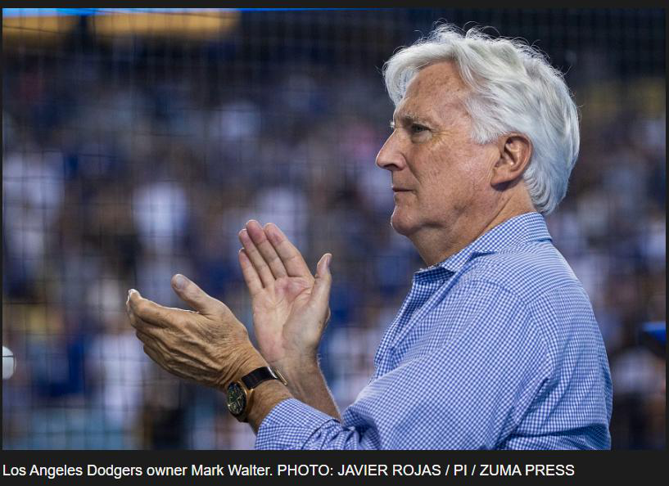
U.S. insurers some $40 billion of debt investments on their books that have been privately graded by Egan-Jones, according to a Wall Street Journal analysis of public data concerning the company whose ratings have come under significant scrutiny from
regulators. Among the biggest holders are insurers controlled by Mark Walter, the chief executive of Guggenheim Partners who owns the Los Angeles Dodgers. Egan-Jones rated about $2.6 billion of loans held by Walter’s insurers, the analysis showed, including debt issued by American Media Productions, a firm controlled by a Walter affiliate
that the Dodgers’ local TV broadcaster.
Hackers Blackstone, Apollo Global Management, Bain Capital, KKR & Co., TPG and Clearlake Capital,as well as other businesses seeking ransom payments, Reuters reported, citing an analysis of internet data. Google said the hacking campaign operates under a range of names, including Redact, Pink, Falcon and Helix. In some cases, the firms met their demands.

A federal judge Cornell Capital’s request to throw out a lawsuit alleging the private-equity firm improperly extracted money from Instant Brands before the kitchen-appliance company’s bankruptcy. U.S. District Judge Margaret Garnett on Aug. 5 ruled the lawsuit, brought by a bankruptcy trustee in 2024 on behalf of the company’s creditors, could proceed. The suit alleges that New York-based Cornell, which manages about $5 billion, used false information to secure a $450 million loan for the Instant Pot maker in 2021, in order to recoup some of its investment after acquiring the company for $615 million in 2019. Cornell has previously denied the claims and declined to comment Friday on the judge’s decision to let the case proceed.
StepStone Group late Thursday a 30% jump in fee-related earnings to $105.6 million, driving a 24% gain in adjusted earnings to about $60.3 million, or 48 cents a share, for its first fiscal 2027 quarter, which ended June 30, compared with the year-ago period. The New York firm's assets under management rose about 23% to $245.4 billion at the end of June from a year ago. But the firm reported a wider net loss, rising to $115.8 million, or $1.41 per share, for the just ended quarter, from a $38.4 million net loss, or 49 cents a share, in the year earlier period. StepStone's Nasdaq-listed shares fell nearly 8.8% Friday to close at $46.41.
About Us
Send us your tips, suggestions and feedback. Write to:

