

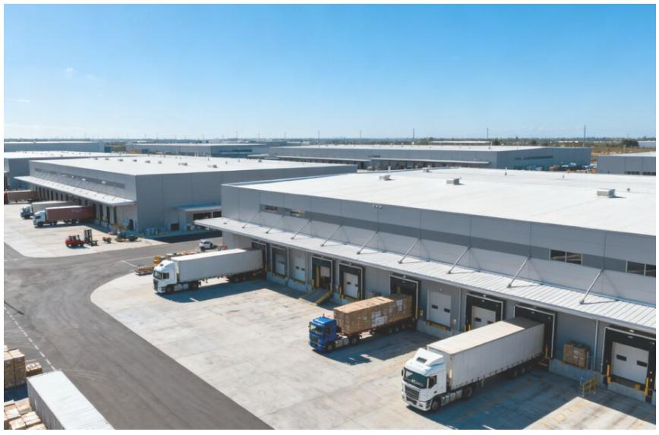
Redfearn Capital, a Delray Beach-based real estate investment firm, and global investment company TPG have acquired an industrial property portfolio valued at $628 million from DRA Advisors. The transaction adds 53 warehouses to the partnership’s holdings and underscores continued investor interest in industrial real estate across South Florida and other major markets.


Key takeaways
•Redfearn Capital and TPG completed the $628 million acquisition.
•The portfolio includes 53 industrial warehouses.
•DRA Advisors was the seller.
•The deal expands the presence of a Palm Beach County firm in the industrial property market.
The transaction represents a major expansion for Redfearn Capital, which is based in Delray Beach. While financial and property-level details were not disclosed, the size of the acquisition makes it one of the more significant recent deals involving a South Florida real estate company.
A large-scale industrial acquisition
The portfolio’s 53 warehouses give the buyers a broad collection of industrial assets rather than a single property. Industrial facilities can serve tenants involved in distribution, logistics, manufacturing and storage, making them an important part of the commercial real estate ecosystem.
The acquisition also provides Redfearn Capital and TPG with exposure to a sizable operating portfolio. The companies did not publicly disclose the locations, occupancy levels, tenant roster or financing structure associated with the purchase.
Partnership between Redfearn and TPG
The deal brings together Redfearn Capital’s regional real estate experience and TPG’s investment platform. Their partnership reflects the growing role of institutional capital in industrial real estate, where investors have continued to seek assets supported by supply-chain activity and demand for warehouse space.
For Redfearn, the transaction increases the scale of its platform and may create opportunities to manage, improve or reposition properties within the portfolio. The company’s participation also highlights the ability of Palm Beach County-based firms to compete for large commercial real estate investments.
DRA Advisors exits portfolio
DRA Advisors, an investment manager focused on commercial real estate, was the seller. The transaction gives DRA an opportunity to realize value from the warehouse portfolio while transferring ownership to a new investment partnership.

The sale comes as industrial properties remain a closely watched segment of the real estate market. Investors continue to evaluate warehouse assets based on factors such as tenant demand, location, operating performance and broader economic conditions.
What the deal means for the market
The $628 million price tag signals continued institutional interest in large industrial portfolios, even as commercial real estate investors remain selective. A transaction of this size can influence valuations and encourage further activity among owners seeking to sell or recapitalize warehouse assets.
The buyers’ next steps, including any planned renovations, leasing initiatives or additional acquisitions, were not disclosed. For now, the purchase establishes Redfearn Capital and TPG as the new owners of a substantial 53-property industrial portfolio.

